A DECISION SUPPORT FRAMEWORK FOR ICT INVESTMENTS IN SMALL AND MEDIUM-SIZED ENTERPRISES (SMES).

**BY;**

**NANDAWULA SHAMIM**

Department of Information Systems, School of Computing and Informatics Technology

College of Computing and Information Sciences, Makerere University

Email: [shamimnandawula200@gmail.com](mailto:shamimnandawula200@gmail.com), Tel: +256 705 954719

A Research dissertation Submitted to School of Graduate Studies for the Study Leading to a Dissertation in Partial Fulfillment of the Requirements for the Award of the Degree of Master of Science in Information Technology of Makerere University

**Supervisors**

Dr. Evelyn Kigozi Kahiigi Dr.Agnes Rwashana Semwanga

Plan A

April, 2023

## **List of Acronyms**

|  |  |
| --- | --- |
| BEIS | Business, Energy, and Industry Strategy |
| COVID-19 | Corona Virus of 2019 |
| CSA | Climate-Smart Agriculture |
| DSR | Design Science Research |
| EU | European Union |
| GDP | Gross Domestic Product |
| ICSB | International Council for Small Business |
| ICSB | International Council for Small Business |
| ICT | Information and Communications Technology |
| IS | Information Systems |
| MCA | Multiple Criteria Analysis |
| OECD | Organization for Economic Cooperation and Development |
| QGCIO | Queensland Government Chief Information Office |
| SME | Small and medium-sized enterprise |
| SPSS | Statistical Package for Social Sciences |
| UNIDO | United Nations Industrial Development Organization |
| USH | Uganda Shillings |
| WLC | Weighed linear combination |

# 

## **1.0 Introduction**

Globally adopting digital technologies has a significant impact on the creation of economic sustainability and social value for SMEs (Vrontis et al., 2022). ICT solutions also played a role in helping small businesses survive and thrive during the COVID-19 pandemic as these teleworked and traded online to cope with the crisis (International Council for Small Business(ICSB), 2022). ICT adoption such as e-commerce brings SMEs and larger companies alike equal access to global markets (Zou & Cheshmehzangi, 2022). Developing countries such as Oman have also adopted ICT in SMEs and these include but are not limited to mobile phones, PCs, PCs with local network connected (intranet), email and electronic data interchange, Internet, and websites (Busaidi et al., 2019). The decision of SME owners/managers to choose ICT products and services depends on many factors, such as the actual benefits they can bring to their core business, employees’ ICT capabilities, the firm’s financial resources capacity, etc. African countries such as Rwanda also have adopted ICT in SMEs through e-commerce, e-business, e-marketing, and other business innovations by integrating ICT into their business operations (Yusuf, 2013).

## **1.1 Background to the study**

Globally, SMEs generate a substantial percentage of Gross Domestic Product (GDP) in most countries, they also account for over 95% of jobs (Busaidi et al., 2019). The SME sector not only generates employment but also creates economic growth, by producing goods and services that may be exported (Lara et al., 2019). The approximately 400 million SMEs are the backbone of economies around the world (Ndiaye et al., 2018).

The decision to adopt IT by SMEs in Indonesia is influenced by technological factors including consideration of benefits, compatibility, and costs; organizational factors which include the readiness of companies to adopt technologies including technological infrastructure readiness, relevant systems, and technical skills; environmental factors include customer/supplier pressures and competitor pressures (Tyasari et al., 2021).In Sweden, Companies stated that they did not have enough knowledge about how ICT might affect their businesses which leads to a problematic situation were decision-makers in SMEs (Ulbrich, 2019).

Previous research in Uganda has indicated that Small and Medium Enterprises (SMEs) are recognized as being critical to the growth of developing economies (Kyakulumbye et al., 2021). According to the World Bank, small and medium enterprises (SMEs) contribute to approximately 80% of Uganda's Gross Domestic Product (GDP) (World Bank, 2021). Micro, Small economy. MSMEs collectively constitute about 90% of private sector production and employ over 2.5 million people (FSD Africa et al., 2015). ICTs have the potential to help SMEs better leverage their informal information resources while minimizing their limitations (Ndiwalana et al., 2006).

Failure to make proper ICT Investments Decisions is one of the most challenging organizational decision-making processes that affect SMEs (Ahmad & Alasmari, 2021).In a study conducted by Kyakulumbye & Shaun 2021, it was found that only 31.8% of SMEs had used ICT in their business operations. The failure of ICT projects in Ugandan SMEs is attributed to a lack of adequate ICT support systems to transform resources into customer-desired quality items and services (Onyinyi & Kaberuka, 2019).SMEs invest in ICT without first assessing their needs or considering how the ICT will be used (Fathian et al., 2008). As a result, these enterprises often end up with ICT that is not fit for purpose and that fails to meet their needs and in some cases, the ICT investment may even make the organization less efficient or effective (Pelser et al., 2017). Lack of ICT expertise, lack of clear objectives, lack of resources, and lack of long-term plans on ICT are some of the causes of poor decision-making on ICT investments (Bankole et al., 2011; Davidaviciene et al., 2020; Fabritz, 2015). These tend to affect the performance of SMEs and lead to failed ICT projects in the end (Modimogale & Kroeze, 2011).

## **1.2 Problem statement**

With the progressive globalization of the economy, ICTs are among the most versatile tools to allow SMEs to compete profitably in larger and more dynamic markets (Osorio-Gallego et al., 2016). However, technology investment decision-making is one of the most challenging organizational decision-making processes (Bakhri, 2015). Ugandan SMEs have a low ICT adoption and many have been struggling to make ICT investment decisions that can enable them to catch up with the global digital economy (Kyakulumbye & Pather, 2021). The failure of ICT projects in Ugandan SMEs is attributed to a lack of adequate ICT support systems to transform resources into customer-desired quality items and services (Onyinyi & Kaberuka, 2019). As a result, these businesses frequently end up with ICT that is unsuitable for their needs, and in some cases, the ICT investment may even make the organization less efficient or effective (Gupta, 2022).

The existing investment decision frameworks such as e ICT-as-a-service Decision Framework, A framework for decision making and evaluation of Information Technology Investment Projects and the General Framework for Information and Communication Technology Investment are not suitable for small businesses in Uganda due to several factors, including the fact that they do not take into account the specific needs of small businesses, do not account for the risks associated with ICT investments, and do not guide how to choose the most suitable information technology investment project. There is a problem of failure to make proper ICT investment decisions. The need, therefore, remains for a decision-support framework for ICT investments in SMEs tailored to the needs of developing countries such as Uganda.

## **1.3 Research questions**

### **1.3.1 Main research question**

What decision support framework can help SMEs to make informed ICT investment decisions?

### **1.3.2 Specific research questions**

1. What are the challenges faced when making decisions for ICT investments in SMEs and what are the requirements for designing a Decision-Support framework for ICT Investments in Small and Medium-sized Enterprises?
2. How can a Decision-Support framework for ICT Investments in Small and Medium-sized Enterprises be designed?
3. To what extent does the designed framework support strategic decision making for ICT Investments in Small and Medium-sized Enterprises?

## 1.4 Objectives

### **1.4.1 Main objective**

To develop a strategic decision-Support framework for ICT Investments in Small and Medium-sized Enterprises.

### **1.4.2 Specific objectives**

1. To investigate the current ICT investments made by SMEs, and to identify any challenges they face when making these investments to determine the requirements for developing a decision support model for ICT investments in SMEs.
2. To design a strategic decision-Support framework for ICT Investments in Small and Medium-sized Enterprises.
3. To test and validate the strategic decision-Support framework for ICT Investments in Small and Medium-sized Enterprises.

## **1.5 Scope**

### **1.5.1 Subject Scope**

This study focused on investigating the challenges faced during strategic decision-making for ICT investments among SMEs which guided the study in determining requirements for design, developing and testing and validating the strategic decision-support framework.

### **1.5.2 Geographical Scope**

The study was carried out based on Small and Medium Enterprises (SMEs) in Kampala district where an SME was selected from each sector in Uganda. These included Zazella Express, Shift Systems, Prodigious Technology Limited (PTL), EzyAgric, and Ensiibuko- S/w devt.

### **1.5.3 Time scope**

This study is limited to a period of one year. This period included writing a proposal, data collection, analysis, designing, and evaluating the framework considered.

## **1.6 Significance**

* The study contributed to body of knowledge of Information and Communication Technology (ICT) and its impact on small and medium-sized enterprises (SMEs).
* The framework provides a structured approach for managers in SMEs to identify and assess the benefits of ICT investments.
* The framework helps SMEs to prioritize ICT investments based on their strategic objectives
* The framework assists enable the management of SMEs in evaluating the risks and costs associated with ICT investments.
* The framework guides the management on how to effectively implement and manage ICT investments.

## **1.7 Justification**

The framework ensures that ICT investments are made strategically and efficiently and helps to ensure that the benefits of ICT are maximized.

The framework helps to ensure that ICT investments are made in a way that is aligned with the strategic goals of the organization, and that the benefits of ICT are realized in a way that is most efficient and effective.

The framework also help to ensure that ICT investments are made in a way that is responsive to the changing needs of the organization, and that the benefits of ICT are maximized.

## **1.9 Key theoretical terms**

**Decision support** refers to any type of information or tools that can be used to help people make better decisions (Rahamathunnisa & Chellappa, 2018).

**Information and Communication Technology (ICT)** Investments refer to the expenditure incurred by an organization on the acquisition, development, and maintenance of ICT Infrastructure and applications such as hardware-software services, etc (Karlsson & Liljevern, 2017).

**Small and Medium Enterprises (SMEs)** are companies with fewer employees than specified thresholds (Al-Herwi, 2019). According to Uganda Investment Authority (UIA, 2017), Small businesses employ between 5 and 49 people and have total assets between UGX 10 million and 100 million, whereas medium businesses employ between 50 and 100 people and have total assets beyond 100 million but less than 360 million.

# **: LITERATURE REVIEW**

## **2.0 Introduction**

This section discusses existing literature about small and medium-sized enterprises and the use of ICT in SMEs. It also details the challenges that deter SMEs from fully exploiting the importance of ICTs and the existing solutions and frameworks to address ICT investment decisions. The literature review enabled the researcher to collect requirements for this study and generate a conceptual framework for making informed ICT investment decisions in SMEs.

## **2.1 Small and Medium Size Enterprises (SMEs)**

SME definitions vary from country to country and are sometimes sector specific. Different authors have usually given different definitions to this category of business. (Abor & Quartey, 2010). They may be defined by the number of employees they have, their rate of turnover, their total borrowing from the financial system, by who or which entity owns majority shareholding, or various combinations of all the above (Ndiwalana et al., 2006). In the case of the manufacturing sector, an enterprise is listed as an SME if the annual sales turnover does not exceed RM25 million or employs less than 150 employees. (Abdulai, 2004). In Nigeria, The Central Bank of Nigeria (CBN) has through its various circulars and intervention fund programs generally defined Small and Medium Enterprises (SMEs) as entities with an asset base of N5 million and not more than N500 million excluding land and buildings with employees between 11 and 200 (Udechukwu, 2003). In Uganda, the Ministry of Finance Planning and Economic Development defines a ‘Small Enterprise’ as an enterprise employing between 5 and 50 people, with an annual sales/revenue turnover total asset of up to Uganda Shillings (USH.) 360 million, and a ‘Medium Enterprise’ as an enterprise that employs more than 50 people with an annual sales turnover or assets of between (USH.) 360 million and 30 billion. (FSD Africa et al., 2015).

## **2.2 Challenge faced by SMEs**

* **Lack of enough funds**

SMEs continue to face the challenge of inadequate funds because they are perceived as high-risk investments by potential funders and as a result (Facundo & Schmukler, 2017), many SMEs are forced to rely on personal savings which limits the growth potential and makes it difficult for them to compete with larger businesses (Yoshino, 2016).

* **Limited access to markets**

According to the report by the United Nations Industrial Development Organization (UNIDO) report, this can be due to a lack of awareness of the relevant markets, or because they lack the necessary contacts and networks like the large business firms (UNIDO, 2007). As a result, they can find it difficult to sell their products and services to a wider audience (Damoah et al., 2017).

* **Access to skills and talent**

SMEs can often find it difficult to attract and retain the skilled employees they need (Damoah et al., 2017). This can be due to a lack of budget for training and development, or because they are located in areas with a limited pool of talent (Stone, 2012). This can limit the ability of SMEs to innovate and grow, as they may not have the necessary skills and talent to do so (Theuri, 2018).

* **Improper ICT investment decisions**

Although ICT has been identified as an important tool for the development of SMEs, many of them do not invest in it and this may be due to financial constraints, lack of technical knowledge, or awareness of its benefits (Thompson & Williams, 2014). Studies reveal that SMEs that have invested in ICT have an edge over their competitors in terms of efficiency and productivity (Tarutė & Gatautis, 2014). However, most of them have not been able to reap the benefits of ICT due to improper decision-making when it comes to making ICT investments (Ayodeji & Andre, 2020).

* **Insufficient resources to acquire loans**

SMEs can often find it difficult to access the finance they need to grow and expand their businesses (Yoshino & Taghizadeh-hesary, 2017). This can be due to various factors such as the structure of the financial sector, awareness of funding opportunities, collateral requirements, small business support services, lack of track record, or simply because they are perceived as too high-risk by lenders (Osano & Languitone, 2016).

## **2.3 ICTs in SMEs**

Information and communication technologies (ICTs) are tools that allow businesses to communicate and exchange information (Das, 2021). The rapid growth and development of information and communication technologies (ICT) have greatly influenced how businesses are operated and managed in the 21st century (Eton et al., 2019). Small and medium-sized enterprises (SMEs) often use ICTs to improve communication and collaboration within the company, as well as to reach new markets and customers (Reza et al., 2011). ICTs can help SMEs increase efficiency and productivity, and reduce costs (Pathan, 2014). In addition, ICTs can help SMEs become more competitive and innovative (Nuamah et al., 2016). Many European Union (EU) and US documents and research results have shown that small and medium-sized enterprises (SMEs) do not take advantage of ICT and e-Business solutions in the way that large companies do. This makes SMEs more vulnerable to changing economic conditions as they have a relatively lower level of competitiveness (Arendt, 2008). SMEs are often seen as flexible organizations that can easily adapt to new technology innovations (OECD, 2018). However, the small size, lack of required knowledge and skills, and slack in committing to provide these resources may hinder the ICT adoption among SMEs (Richie and Brindley, 2005; Lucchetti and Sterlacchini, 2004; Boekhoudt and van der Stappen, 2004;

## **2.4 ICT Investment Decision-making in SMEs**

ICT investment decision-making is one of the challenging organizational decision-making processes (Rantapuska & Ihanainen, 2008). Although there is a multitude of methods and models created for effective information system evaluation and selection, many organizations fail in their ICT investments (Garcia 2003, Lyytinen and Robey 1999). The system buyers do not make the effort needed for a successful ICT investment decision (Comella-Dorda et al. 2002) and most of them do not even have the decision-making tools, methods, or support. Especially in small and medium-sized enterprises ICT management is quite often based on short-term, informal, and ad hoc practices (Doukidis et al 1996, Burgess 2002). (Rantapuska & Ihanainen, 2007). The decisions are mostly based on tacit knowledge such as intuition, experience, attitudes, and values. External sources such as user events, benchmarking, and face-to-face interaction with different suppliers, are not used so often (Bharati and Chaudhury, 2006). In these circumstances, the supplier may take too big of a role in the decision-making (Brereton, 2004).

## **2.5 State of the art of Existing ICT Investment and decision support frameworks**

### **2.5.1 The ICT-as-a-service Decision Framework**

The ICT-as-a-service Decision Framework was developed by the Queensland Government Chief Information Office (QGCIO) to support organizations in making well-informed and evidence-based decisions to either strategically transition their ICT workload (system/application/data) into an as-a-service delivery model, or to deliver via traditional in-house methods, or to combine these two methods (QGCIO, 2014). This framework provides several tools and techniques specific to ICT-as-a-service decision-making. The framework provides a set of criteria against which organizations can assess the benefits and risks of moving to an ICT-as-a-service model. Before using the ICT-as-a-service Decision Framework, agencies must have clearly defined the business requirements for the ICT workload to be examined using the framework. The framework is illustrated below;

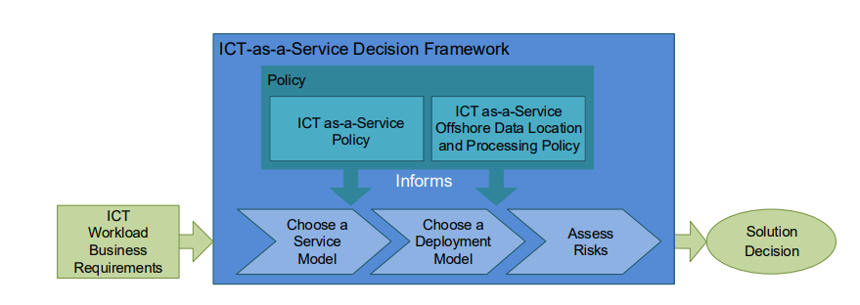

*Figure 2.1: The ICT-as-a-service Decision Framework* (Source: QGCIO, 2014).

### **2.5.2 A framework for decision making and evaluation of Information Technology** **Investment Projects**

This framework is designed to help organizations select and implement IT projects that will create value and achieve strategic objectives and this can be used for both small and large projects and can be adapted to different organizational contexts (Ali & Younes, 2012). The decision-making process of investments in IT is summed up in four distinct steps as illustrated and discussed below.

Analysis and planning, Evaluation of costs and benefits, Selection and implementation and Post-implementation evaluation.

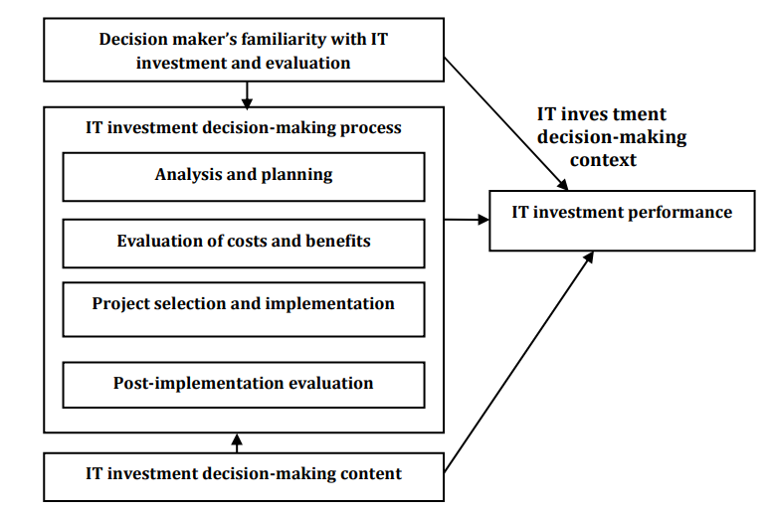

*Figure 2.2 :* A framework for decision making and evaluation of Information Technology

Investment Projects (QGCIO, 2014) (Source: Ali & Younes, 2012)

### **2.5.3 A General Framework for Information and Communication Technology Investment**

This framework was developed to assist ICT investors and decision-makers by providing a detailed analysis of previously invested amounts in ICT which helps to decide on future ICT investments (Saleem et al., 2012). This framework can assess the numerous measurement factors such as; service performance, risk factors, utilization of resources, financial return, public value, etc. Starting from analyzing the context of ICT investment, stakeholder analysis helps to extract the value-measuring variables. This study defined six stages of evaluating and deciding on ICT investments and these are illustrated and discussed in the framework below; Stage 1: Examine the Context of ICT Investment, Stage 2: Types of ICT Investment, Stage, Stage 4: Value Measuring Variables / Impact Factors, Stage 5: Evaluation Value(s) Type., Stage 6: Final Return Value.

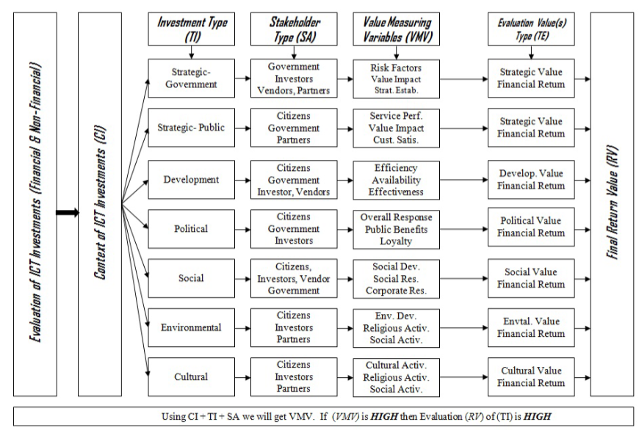

Figure 2.3: A General Framework for Information and Communication Technology Investment (Source: Saleem et al., 2012).

### **2.5.4 Gap analysis of the ICT Investment and decision support frameworks**

There are several decision-making frameworks available, but they are not suitable for small and medium-sized enterprises (SMEs) due to their limitations. For instance, these frameworks do not address the specific business needs of SMEs, do not provide guidance on selecting the most suitable information and communication technology (ICT) investments, and do not adequately account for risks. The table below further illustrates these weaknesses.

|  |  |  |
| --- | --- | --- |
| **Framework** | **Strengths** | **Weakness** |
| The ICT-as-a-service decision Framework (QGCIO, 2014) | * provides a clear and concise guide for agencies when making decisions about the adoption of ICT as a service. * Easy to follow and understand. | The ICT-as-a-service decision Framework does not adequately consider the needs of small businesses as it is primarily designed for large businesses. |
| A framework for decision making and evaluation of Information Technology Investment Projects (Ali & Younes, 2012) | * Provides a systematic and structured approach for making decisions * It is based on several key factors that should be considered when making these decisions. * Was developed for both small and large businesses. | * It does not address the issue of risk. * Does not guide how to select the most appropriate information technology investment project * The framework does not provide a mechanism for monitoring and evaluating the progress of information technology investment projects. |
| General Framework for Information and Communication Technology Investment (Saleem et al., 2012). | * Provides a comprehensive and systematic approach to ICT investment * Provides guidance on how to assess the benefits and risks associated with ICT investment, which can help organizations make more informed decisions about their ICT spending. | * Does not provide a detailed roadmap for implementation * Does not consider the monetary value of the ICT project. * Does not consider the specific needs of different organizations, |

## **2.6 Decision support frameworks**

Decision making is an important aspect of business management, and in the digital age, it is even more important for organizations to make informed decisions about their investments in Information and Communication Technology (ICT) (Naveem et al., 2016). This is especially true for small and medium-sized businesses (SMEs), which face unique challenges and constraints in their decision-making processes (Ismail Albalushi & Naqshbandi, 2022). These various frameworks are used in decision making and these are described below together with their strengths and weaknesses however they don’t apply to SMEs

### **2.6.1 consensus-driven decision support framework**

This framework aims to aid the targeting of climate-smart agriculture (CSA) at the national level (Brandt et al., 2015). This framework integrates quantitative, spatially explicit information such as vulnerability indicators (e.g. soil organic matter, literacy rate, and market access) and proxies for CSA practices (e.g. soil fertility improvement, water harvesting, and agroforestry) as well as qualitative opinions on these targeting criteria from a broad range of stakeholders. The analytic hierarchy process and goal optimization approaches are utilized to quantify collective, consensus-oriented stakeholder preferences on vulnerability indicators and CSA practices.

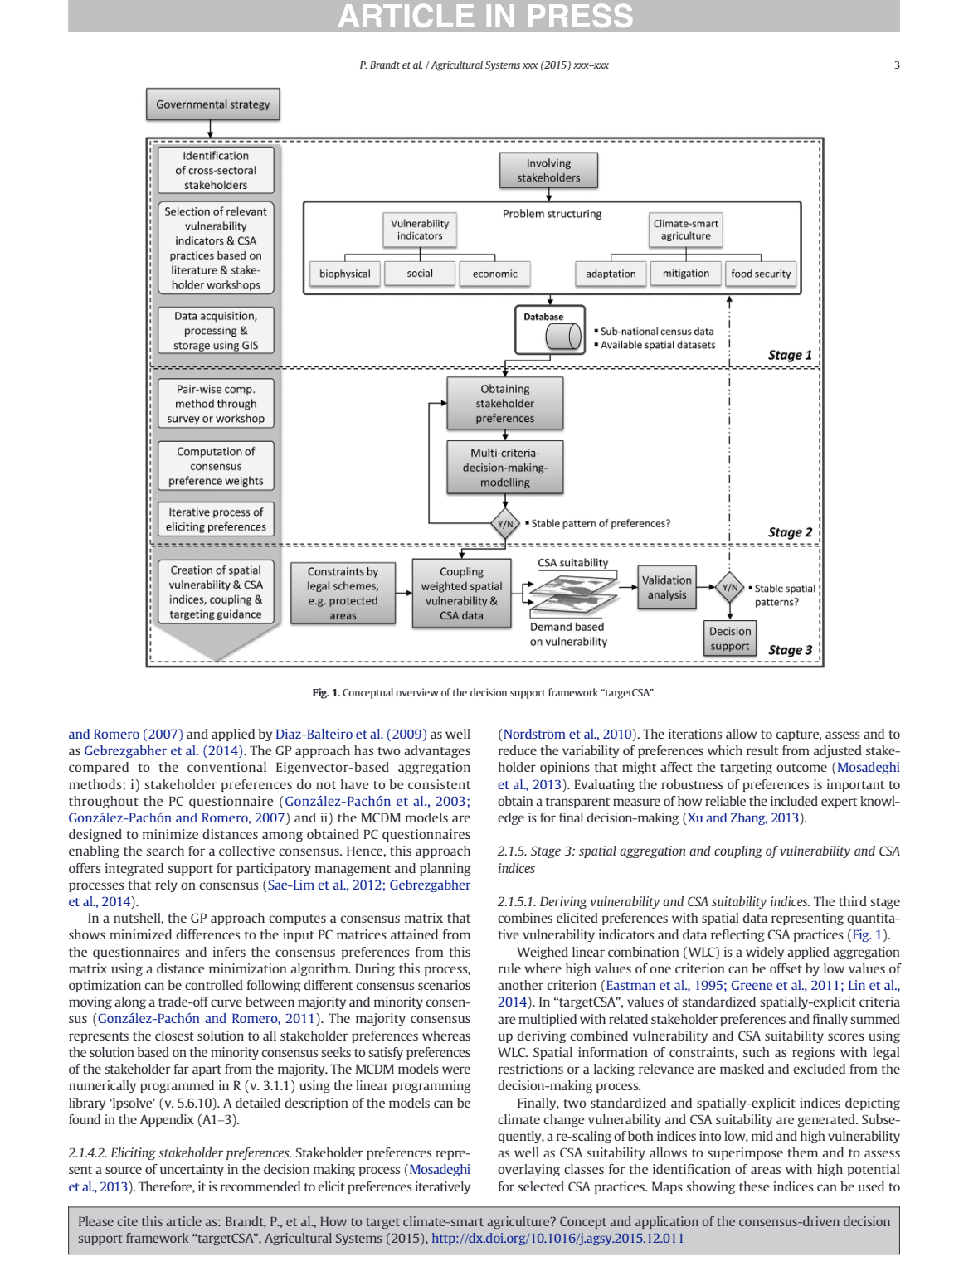

Figure 2.4: Consensus-driven decision support framework (Source: Brandt et al., 2015).

### **2.6.2 A multicriteria decision support framework**

The decision support framework was developed for assessing alternative wind park locations using MCA tools (Stratigea & Grammatikogiannis, 2012). It uses two multicriteria evaluation techniques are used (ELECTRE I and REGIME) as tools that can relieve ‘method uncertainty’ and deal with conflicts and different perspectives in the decision-making process.

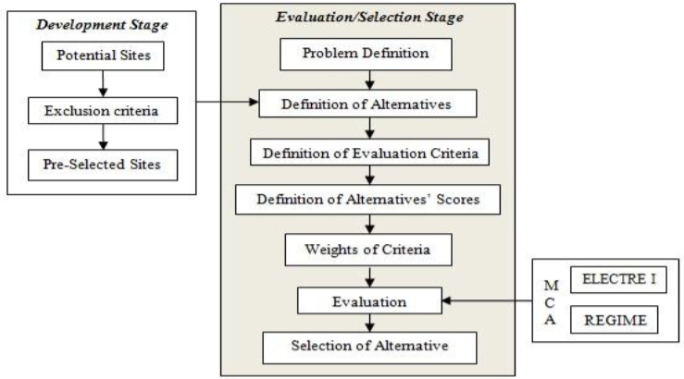

Figure 2.5: A multicriteria decision support framework (Source: Stratigea & Grammatikogiannis, 2012).

### **2.6.3 Decision support system framework**

This is a decision-support framework that was developed for guiding the development of decision-making systems (Graymore et al., 2012). In this framework below, once a problem has been identified stakeholder consultation is used to clearly define the problem, determine management options or alternatives and develop the criteria on which to base the decision. Data is then collected for each of the criteria and then the criteria are considered simultaneously to give a ranking of the possible options. This is done in a consistent and repeatable way to give reliable results each time the tool is used. Several methods have been used to do this final step including multiple criteria analysis (MCA), modeling predicted outcomes of the alternatives, factor analysis, or fuzzy set theory

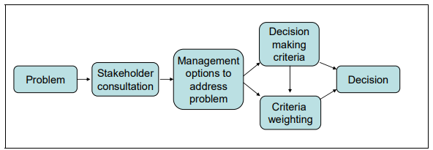

Figure 2.6: Decision support system framework (Source: Graymore et al., 2012).

## **2.7 Analyzing the gaps between the existing decision support framework**

After reviewing the current decision support frameworks in this study, it has been identified that there is a gap that can be filled by the proposed ICT investment framework. While the existing frameworks are useful, they lack certain components, such as being restricted to specific sectors like agriculture and therefore require generalization. Additionally, they may not be applicable to ICT investments, fail to consider all factors that affect SME investments, and other limitations that are outlined in the table below.

|  |  |  |
| --- | --- | --- |
| **Framework** | **Strengths** | **Weaknesses** |
| consensus-driven decision support framework (Brandt et al., 2015) | it is based on the consensus of the group, which means that all members of the group agree with the decision. | Was developed for smart agriculture  it can be time-consuming to reach a consensus, |
| A multicriteria decision support framework (Stratigea & Grammatikogiannis, 2012) | It is effective in guiding decision-makers to identify the most suitable location for a wind park. | It is limited to only wind parks, and this may not apply to other decisions such as ICT investments |
| Decision support system framework (Graymore et al., 2012) | It is based on a solid understanding of the decision-making process and the needs of decision-makers. | It does not consider all the other factors that are considered for deciding such as risks assessment |

### **2.7.1 Conceptual framework**

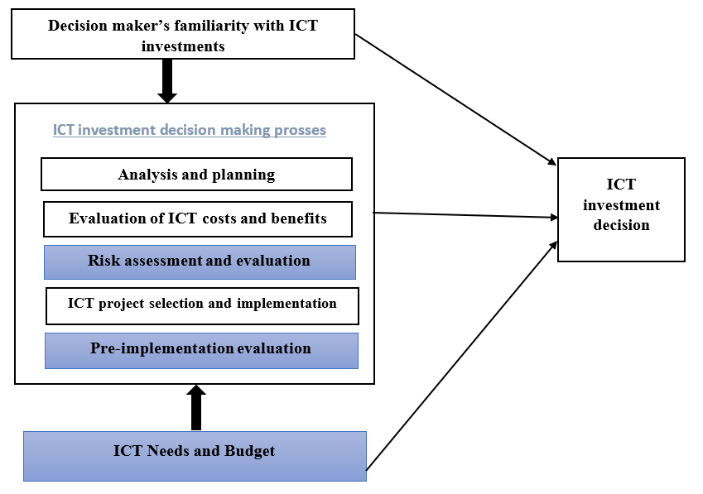This research study proposes a conceptual Framework for Decision-Support of ICT Investments in Small and Medium-sized Enterprises by using variables and processes obtained from the framework for decision-making and evaluation of Information Technology Investment Projects (Ali & Younes, 2012). This study proposes the addition of components, and these include Risk assessment and evaluation, Pre-implementation evaluation, ICT needs, and Budget as illustrated below.

Figure 2.7: Conceptual framework for strategic decision support in ICT investments in SMEs

# **: METHODOLOGY**

## **3.0 Introduction**

This section involves research methodologies and approaches that were used to conduct the study. This also includes the most appropriate tools that were used in data collection and analysis as well as the study sample and target population for the research study. This was discussed in various sections as follows.

## **3.1 Research design**

Research design is the overall plan for conducting the research project, and it includes all the specific steps and methods that are used to complete the project (Boru, 2018). The purpose of research design is to create a plan for how the research was conducted and to specify what data was to be collected, what research questions were asked, and what data sources were used to complete the study (Bostley, 2019).The main activities of the research design in this study consist of a critical literature review, a descriptive field study for challenges faced when making ICT investments in SMEs, a framework design and evaluation of a decision-Support framework for ICT Investments in SMEs.

## **3.2 Research Approach**

Research approaches are research plans and procedures that cover everything from general assumptions to detailed data collecting, analysis, and interpretation methodologies(Creswell, 2014).

### **3.1.1 Inductive Approach**

The inductive approach is a research method that involves moving from specific observations to more general theories as often used in the social sciences and natural sciences (Çapuk, 2006).

### **3.1.2 Deductive Approach**

A deductive approach is an approach to research in which a hypothesis is derived from existing theory and is then tested through observation and experimentation (Koffi, 2019). **This approach begins with an abstract, logical relationship between concepts before moving toward tangible empirical evidence(H. Ali & Birley, 1999).**

### **3.1.3 Abductive Approach**

The Abductive approach is a method of reasoning that involves deriving a conclusion based on limited information often used in cases where the available evidence is insufficient to allow for deductive or inductive reasoning(Haig, 2022). In some cases, the abductive approach may be the only option available to conclude.

### **3.1.4 Proposed Research Approach for the study**

To fully understand the problem at hand, identify its origins, and finally draw a firm conclusion, the abductive approach was used in this study because the framework was built on existent theories and data collected from the field.

## **3.2 Research Methodology**

The research methodology is the process used to collect and analyze data for a research study (Heath, 2021). The proposed research methodology for the study is designed science research to provide a review of the relevant literature to be conducted to gain an understanding of the current state of knowledge regarding the research topic and a survey was administered to a sample of individuals who are knowledgeable about the research topic. This research methodology was more appropriate because design science research contributes to the determination and explanation of pertinent organizational issues, proof that there are solutions in the current IT knowledge base, creation, and presentation of a novel IT item as well as a thorough assessment of the IT artefact enabling the assessment of its utility (March & Storey, 2008). The three inherent research cycles that design science research overlays are the Relevance Cycle, the Rigor Cycle, and the Central Design Cycle (Hevner, 2007). The Relevance Cycle links the design science activities with the context of the research project and the Rigor Cycle links the design science activities with the knowledge base of scientific foundations, experience, and expertise that informs the research project Hevner & Chatterjee, 2010).

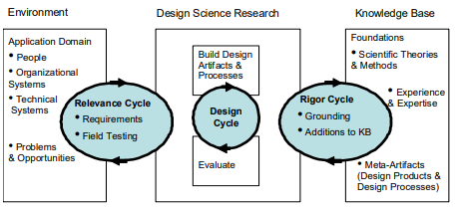

## **3.3 Cycles of Design Science Research**

### **3.3.1 The relevance cycle**

The relevance cycle begins design science research with an application context that not only offers the study's requirements but also specifies acceptance criteria for the final assessment of the research findings (Hevner, 2007). This research involved studying the challenges Small and Medium Enterprises (SME) face with making ICT investments decisions. First, this involved analyzing the applicability and adaptability of SMEs to ICT it is that they use on a short-term basis and therefore creating a challenge in investing in ICT. Data regarding the decision-making in investment in ICT in SMEs was gathered from the stakeholders. These included the managers and employees of SMEs within Kampala because managers take part in making the decisions of investing and the employees work on effecting the decisions made.

### **3.3.2 The Rigor cycle**

The Rigor Cycle incorporates domain information and expertise from the foundational knowledge base, together with grounding theories and methodologies, into the research and adds the new knowledge produced by the research to the expanding knowledge base (Hevner, 2007).

**Application of the Rigor cycle in this study**

To assess the research on how to choose which ICT investments to make in utilizing the knowledge base, a literature review was conducted for this study. The researcher reviewed various ICT decisions frameworks and these include; The ICT-as-a-service decision Framework (QGCIO, 2014), A framework for decision-making and evaluation of Information Technology Investment Projects (Ali & Younes, 2012), and the General Framework for Information and Communication Technology Investment (Saleem et al., 2012). The study adopted and extended the framework for decision-making and evaluation of Information Technology Investment Projects (Ali & Younes, 2012) which was modified to address the aspect of poor decision-making of ICT investments in SMEs.

### **3.3.3 The design cycle**

Any study effort in design science revolves around its internal design cycle which involves the creation of an artefact, its evaluation, and the subsequent feedback to improve the design occurs more quickly in this cycle of research activities (Hevner, 2007). This stage of design science entails the creation of the artifact, which can be a model, construct, method, or instantiation (Hevner et al., 2004).

**Application of design cycle in this study**

The researcher developed a framework for supporting the decision-making of ICT investments in small and medium-sized enterprises. This was based on the identified stakeholder needs throughout the relevance cycle, as well as theories and approaches from the current knowledge base. This framework was created and tested in the context of SMEs where an SME was selected from each sector in Uganda which clarified how the framework functions as the researcher uses the Unified Modelling Language to assess the specified stakeholders from specific case studies. The researcher employed a Microsoft Visio tool which provides a creative solution with a variety of built-in capabilities that makes it easy to view business process flows connected to data. This was therefore be evaluated using the discourse analysis method giving room for the design cycle to enable the researcher to achieve objective three of the study.

**3.4 Target population**

A population is made up of individuals, things, cases, and other observation units that are of interest and meet the sample conditions for inclusion in a study (Taherdoost, 2016). The study population was made up of a 3 SMEs i.e. Zazella Express, Shift Systems and Prodigious Technology Limited (PTL) company.

Zazella has a total of 7 employees inclusive of 3 decision makers, Shift Systems has a total of 3 employees inclusive of 2 decision makers while Prodigious Technology Limited (PTL) company has a total of 9 employees inclusive of 4 decision makers.

## **3.5 Sampling**

A sample is a group of people, objects, or items chosen from a larger population for measurement, and it is representative of the population to ensure that the research sample's conclusions are generalizable to the full population (Etikan & Bala, 2017).

### **3.5.1 Target population**

The researcher is unlikely to be able to collect data from all instances to answer the study questions hence the need to choose a sample from a given population. A population is made up of individuals, things, cases, and other observation units that are of interest and meet the sample conditions for inclusion in a study (Taherdoost, 2016). The study population was made up of 5 SMEs representing the agriculture and IT service sector in Uganda because that is the study scope.

### **3.5.2 Sampling Technique**

In this study, a purposive sampling technique was employed since it allows the researcher to determine what information is required and to choose a specific subset of persons from whose data is to be collected (Etikan, 2016).

### **3.5.3 Sample size**

The sample size included 5 SMEs from the two sectors representing the economy of Uganda namely; Agriculture, and IT services. Using Krejcie and Morgan Table for determining sample size (Appendix III) the following is the sample size for the various case studies that was used in this study.

|  |  |  |
| --- | --- | --- |
| Company | Target population | Sample size |
| Zazella Express | 7 | 7 |
| Shift Systems | 3 | 3 |
| Prodigious Technology Limited (PTL) | 9 | 9 |
| EzyAgric | 25 | 24 |
| Ensiibuko- S/w devt | 15 | 15 |
| Total Sample size | 58 | |

## **3.6 Consent**

Shaha et al., (2019) stated that a voluntary agreement, collaboration, or assent offered without pressure is characterized as consent. Before taking part in the study, all volunteers were required to sign a written agreement to engage willingly in this investigation.

## **3.7 Exclusion and inclusion criteria**

The exclusion criteria for this study included SMEs that are not located within Kampala district as well as businesses not operating under SMES. The inclusion criteria included SMEs in Kampala district and the key participants were the business owners and employees who make decisions and work with the decisions made respectively because these are the key players in ICT decisions and usage.

## **3.10 Ethical Consideration**

Ethics refers to the principles that guide a person's behavior and in research, ethics refers to performing what is morally and legally correct (Parveen & Showkat, 2017). Before starting this research project, obtained permission from Makerere University's School of Computing and Information Sciences, which is part of the department of information technology. This made sure that all research activities follow ethical guidelines and meet the different ethical standards in the organizations which we got data from.

# **:** **PRESENTATION OF FINDINGS OF THE STUDY**

## **4.0 Introduction**

## **4.1 Demographics of the Participants**

The demographic analysis of respondents provides key insights into the workforce of SMEs in Kampala, which is essential for understanding the context of ICT investment decision-making within these organizations. Here is a summary of the findings.

Table 4:1 Demographic characteristics of participants

|  |  |  |  |
| --- | --- | --- | --- |
| Respondent characteristic | | Frequency (N=46) | Percentage % |
| Age Group | 18-25 years | 24 | 52.2 |
| 26-30 years | 15 | 32.6 |
| 31-40 years | 5 | 10.9 |
| 41-50 years | 2 | 4.3 |
| 50 and above | 0 | 0 |
| Gender | Male | 27 | 58.7 |
| Female | 19 | 41.3 |
| Highest level of formal education | Certificate | 8 | 17.4 |
| Diploma | 4 | 8.7 |
| Bachelors | 30 | 65.2 |
| Masters | 4 | 8.7 |
| PHD | 0 | 0 |
| Role within the organization | CEO/Managing Director/Owner | 6 | 13 |
|  | Senior Manager/Executive | 6 | 13 |
|  | Middle Manager/Supervisor | 7 | 15.2 |
|  | Junior Staff/Operational | 27 | 58.7 |
| Years spent in each role | Less than a year | 16 | 34.8 |
|  | 1-3 years | 20 | 43.5 |
|  | 3-5 years | 5 | 10.9 |
|  | 5 years or more | 5 | 10.9 |

1. **Age Group**

The majority of the respondents fall within the 18-25 year age group, representing 52.2% of the sample. This is followed by 32.6% in the 26-30 year range, 10.9% in the 31-40 year range, 4.3% in the 41-50 year range, and none in the 50 and above category. The dominance of younger respondents (18-30 years) suggests a relatively youthful workforce in SMEs within Kampala. This age distribution could imply a higher propensity for adopting new technologies, as younger individuals tend to be more tech-savvy and open to ICT innovations.

1. **Gender**

The gender distribution among the respondents shows that 58.7% are male and 41.3% are female.

The gender disparity, although not extreme, indicates a slight male dominance in the workforce of SMEs in Kampala. This may have implications for diversity and inclusivity within these organizations.

1. **Highest Level of Formal Education**

Regarding education, 17.4% of respondents hold a certificate, 8.7% a diploma, 65.2% a bachelor's degree, and 8.7% a master's degree. None of the respondents have a PhD. The high percentage of respondents with bachelor's degrees (65.2%) indicates a relatively well-educated workforce. This educational background could enhance the capacity of SMEs to understand and implement ICT solutions effectively.

1. **Role Within the Organization**

Respondent roles within their organizations are distributed as follows: 13% are CEO/Managing Director/Owner, 13% are Senior Manager/Executive, 15.2% are Middle Manager/Supervisor, and 58.7% are Junior Staff/Operational. Most of junior staff and operational roles (58.7%) highlights a workforce primarily engaged in day-to-day operations rather than strategic decision-making.

1. **5. Years Spent in Each Role**

In terms of tenure, 34.8% of respondents have been in their role for less than a year, 43.5% for 1-3 years, 10.9% for 3-5 years, and 10.9% for 5 years or more. The significant proportion of respondents with less than 3 years in their roles (78.3%) indicates a relatively high turnover or recent entry of employees in these positions. This could impact the stability and continuity of strategic decision-making processes. On the positive side, new employees might bring fresh perspectives and innovative ideas to ICT investment decisions.

## **4.2 Decision support and ICT tools**

A thorough examination of the dynamics behind ICT investment decision-making processes within Small and Medium-sized Enterprises (SMEs) is contained in the section on Decision Support and ICT Tools. This section explores the depth of information obtained from stakeholder views and survey responses, providing light on the environment surrounding ICT investments.  
  
This section presents the key factors in ICT investment decision-making, from stakeholder involvement and level of competence to prevalent decision-making techniques and expected benefits, via careful analysis and interpretation. A detailed knowledge of the challenges faced, suggested solutions, and the possible game-changing effects of successful ICT investments on organizational performance and strategic goals are provided in each subsection.

### **4.2.1 Assessing the expertise in Using ICT Tools and Technologies**

The survey results indicate a diverse range of expertise levels among respondents in using ICT tools and technologies. A significant portion of the respondents (45.7%) classify themselves as having intermediate expertise. This suggests that nearly half of the workforce has a solid foundational understanding and practical experience with ICT tools but may still require further training to handle more complex tasks. Additionally, 32.6% of respondents identify as advanced users, indicating a substantial group that can leverage ICT tools for more sophisticated and strategic purposes. 13% of respondents consider themselves experts, reflecting a smaller but crucial segment of highly skilled individuals capable of driving innovation and leading ICT initiatives within their organizations. Conversely, 8.7% of respondents are at the beginner level, highlighting a need for basic ICT training and support to bring these users up to speed. Overall, the majority of respondents possess at least an intermediate level of ICT proficiency, which is a positive indicator for the adoption and effective use of ICT investments in SMEs as shown in figure 4.1 below.

Figure 4.1 Showing the level of ICT expertise of stakeholders

### **4.2.2 Frequency of ICT Tools and Technologies Usage in Job Roles**

The results on the frequency of ICT tools and technologies usage reveal that a significant majority of respondents (67.4%) use ICT tools every day, indicating that these tools are integral to their daily job functions. This high frequency of use underscores the importance of ICT in the operational activities of SMEs in Kampala and highlights the reliance on technology for day-to-day business processes. A smaller portion of respondents (19.6%) use ICT tools once or twice a week, suggesting that while ICT is important to their roles, it may not be essential for their daily tasks. Additionally, 10.9% of respondents use ICT tools occasionally, about once or twice a month. This indicates that some roles within SMEs may not require constant interaction with ICT tools, potentially due to the nature of their job functions or the specific needs of their tasks.

A very small percentage (2.2%) of respondents reported using ICT tools rarely, less than once a month. This minimal usage might be reflective of positions that have minimal interaction with technology, or possibly a lack of access to ICT resources. The predominance of daily ICT usage among the majority of respondents points to the critical role of technology in enhancing efficiency, productivity, and overall business operations within SMEs. This frequent usage pattern suggests that investments in ICT are likely to have a significant impact on the performance and competitive advantage of these enterprises.

Figure 4.2 Frequency of ICT Tools and Technologies Usage in Job Roles

### **4.2.3 Training and Support for Effective Use of ICT Tools in Organizations**

When asked whether they had received any training or support to help them use ICT tools and technologies more effectively, 71.7% of respondents indicated that they had, while 28.3% reported that they had not received such support. The fact that a significant majority of respondents have received training or support suggests that many SMEs in Kampala recognize the importance of equipping their employees with the necessary skills to use ICT tools effectively. This proactive approach to training is crucial for ensuring that employees can leverage technology to enhance productivity, efficiency, and overall business performance.

Figure 4.3 Showing training and support for effective ICT tools

### **4.2.4 Current ICT Tools and Technologies Used in the Company**

The survey results on the types of ICT tools currently being used in companies reveal a diverse array of technologies that SMEs in Kampala are integrating into their operations. The findings are as follows; Computer Hardware: 73.9%, Cloud Computing: 30.4%, E-commerce Platforms: 26.1%, Virtual Meetings: 52.2%, Software: 56.5%, social media: 60.9% and Mobile Devices: 69.6%.

The high usage of computer hardware (73.9%) and mobile devices (69.6%) underscores the fundamental role these tools play in the daily operations of SMEs. This widespread adoption indicates that the basic infrastructure for ICT is well established within these organizations.

The substantial use of software (56.5%) and virtual meetings (52.2%) highlights the importance of digital solutions and remote collaboration tools in enhancing productivity and communication. This is especially relevant in the current business environment where flexibility and remote work capabilities are crucial.

The usage of social media by 60.9% of respondents shows a strong emphasis on digital marketing and customer engagement. Social media platforms provide SMEs with valuable opportunities to reach and interact with their target audience, thereby driving brand awareness and customer loyalty.

Cloud computing is used by 30.4% of respondents, reflecting a growing but still moderate adoption rate. This suggests that while some SMEs are leveraging the scalability, flexibility, and cost-efficiency of cloud services, there is still potential for increased uptake. Cloud computing can provide significant advantages in terms of data storage, accessibility, and collaborative work environments.

E-commerce platforms are utilized by 26.1% of respondents, indicating that a smaller but significant segment of SMEs are engaging in online sales and services. This adoption is crucial for businesses looking to expand their market reach and offer convenient purchasing options to their customers.

Overall, the data indicates a strong reliance on essential ICT tools such as computer hardware, mobile devices, and software as shown in the figure 4.4.

Figure 4.4 Showing current ICT tools and technologies used

### **4.2.5 Main Challenges in Using ICT Tools and Technologies**

The survey results on the main challenges faced by SMEs when using ICT tools and technologies highlight several key issues. The challenges are Technical Problems or Glitches: 60.9%, Lack of Access to Technology: 32.6%, Insufficient Training or Support: 30.4%, Lack of Skills/Expertise: 19.6%, Others: 11%. Other Suggested challenges included low funding of ICT investments, Slow internet service, Limited access to some tech tools.

The prevalence of technical problems or glitches, reported by 60.9% of respondents, indicates a significant barrier to effective ICT use. This suggests that maintaining reliable and functional ICT systems is a major concern for SMEs. Frequent technical issues can disrupt business operations, reduce productivity, and cause frustration among employees.

Lack of access to technology, cited by 32.6% of respondents, points to an issue with the availability and affordability of necessary ICT tools and resources. This challenge may stem from financial constraints or logistical difficulties in obtaining and deploying suitable technology.

Insufficient training or support, experienced by 30.4% of respondents, underscores the need for better educational resources and ongoing technical assistance. Without adequate training, employees may struggle to use ICT tools effectively, leading to suboptimal utilization and reduced benefits from ICT investments.

The lack of skills or expertise, noted by 19.6% of respondents, highlights a skills gap that can hinder the efficient use of ICT tools. This gap can be addressed through targeted training programs and professional development opportunities to enhance the ICT competencies of the workforce.

Figure 4.5 Showing main challenges in using ICT tools and technologies

### **4.2.6 Impact of ICT Investments on Organizational Performance**

The survey results on how ICT investments can help improve organizational performance reveal the following insights. Improve Efficiency and Productivity: 78.1%, Enhance Communication and Collaboration: 69.6%, Expand Customer Reach and Engagement: 67.4%, Streamline Processes and Operations: 43.5%, and Others: 4.4%.

The findings suggest that a significant majority of respondents (78.1%) believe that ICT investments primarily improve efficiency and productivity within their organizations. This indicates that ICT tools are perceived as essential for optimizing workflows, reducing time wastage, and enhancing the overall output of employees and processes.

A substantial portion (69.6%) of respondents also recognize the role of ICT in enhancing communication and collaboration. This underscores the importance of technologies such as virtual meetings, messaging platforms, and collaborative software in facilitating effective teamwork and information sharing, both within the organization and with external stakeholders.

Similarly, 67.4% of respondents highlight the potential of ICT investments to expand customer reach and engagement. This suggests that SMEs see value in using digital marketing tools, e-commerce platforms, and social media to connect with a broader audience and foster stronger customer relationships.

Streamlining processes and operations is noted by 43.5% of respondents as a benefit of ICT investments. This reflects the role of technology in automating routine tasks, integrating various business functions, and improving overall operational efficiency.

The additional comments (4.4%) indicate that some respondents see ICT as a means to generally improve SME businesses and ensure timely accomplishment of tasks. These insights reinforce the multifaceted benefits of ICT, which extend beyond the primary categories mentioned.

Figure 4.6 Showing the impact of ICT investments on organizational performance

### **4.2.7 Current ICT Investment Strategies in the Organization**

The survey results on how organizations currently invest in ICT reveal the following investment practices. Purchasing Hardware or Software: 63%, Upgrading Existing Technology: 56.5%, Implementing New Systems or Processes: 54.3%, Developing New Products or Services That Require ICT: 32.6%, and Other: 2.2%.

The majority of organizations (63%) prioritize purchasing hardware or software as a key area of ICT investment. This highlights the fundamental need for reliable and up-to-date technology infrastructure to support business operations. By acquiring new hardware and software, SMEs can enhance their capabilities and improve overall efficiency.

Upgrading existing technology is also a significant investment focus, noted by 56.5% of respondents. This indicates that many organizations recognize the importance of maintaining modern and efficient systems by continually updating their technology. Regular upgrades ensure that businesses can keep pace with technological advancements and avoid the pitfalls of outdated systems.

Implementing new systems or processes is another critical investment area, with 54.3% of respondents highlighting this practice. This shows that organizations are not only interested in acquiring new technologies but also in integrating them into their operational workflows to optimize processes and drive innovation.

Developing new products or services that require ICT is reported by 32.6% of respondents. This suggests that a significant portion of SMEs are leveraging ICT to expand their offerings and create new business opportunities. By investing in the development of ICT-enabled products and services, organizations can enhance their market competitiveness and drive growth.

A small percentage (2.2%) of respondents mentioned other investment practices, such as conducting ICT sensitizing trainings. This reflects an understanding of the importance of not only acquiring technology but also ensuring that employees are well-versed in its use. Training initiatives can help maximize the return on ICT investments by enabling staff to effectively utilize the new tools and systems.

Figure 4.7 Showing current ICT investment strategies in the organization

### **4.2.8 Key ICT Investments Made by the Organization in the Past Year**

The survey results indicate the following key ICT investments made by organizations in the past year. Hardware (e.g., computers, servers, mobile devices): 37%, Software (e.g., applications, platforms): 30.4%, IT Infrastructure (e.g., networking, security): 17.4%, and Training and Development: 15.2%.

The significant investment in hardware (37%) suggests that organizations prioritize acquiring tangible assets such as computers, servers, and mobile devices to support their day-to-day operations. These hardware investments are essential for providing employees with the necessary tools to carry out their tasks efficiently and effectively.

Software investments (30.4%) are also prominent, indicating a focus on acquiring or upgrading applications and platforms to enhance business processes and capabilities. Investing in software solutions enables organizations to streamline workflows, improve collaboration, and leverage advanced functionalities to stay competitive in the market.

IT infrastructure investments (17.4%) encompass networking and security solutions, reflecting a recognition of the importance of building a robust and secure technological foundation. A reliable IT infrastructure is crucial for ensuring seamless connectivity, data protection, and system integrity, which are essential for business continuity and risk management.

Training and development initiatives (15.2%) are also recognized as key ICT investments, indicating a commitment to upskilling employees and enhancing their proficiency in using ICT tools and technologies. Investing in training programs helps organizations maximize the ROI of their ICT investments by ensuring that employees are equipped with the knowledge and skills needed to leverage technology effectively.

Figure 4.8 showing ICT investments made by the organization in the past year

### **4.2.9 Decision-Making Process for ICT Investments in the Organization**

The survey results indicate the following approaches to ICT investment decision-making within organizations. Top-down approach (decisions made by senior management): 41.3%, Bottom-up approach (decisions made by front-line staff): 8.7%, and Collaborative approach (decisions made through consultation and consensus-building): 50%.   
A significant portion of organizations (41.3%) employ a top-down approach, where ICT investment decisions are primarily made by senior management. This suggests that strategic decisions regarding technology investments are centralized and driven by the vision and objectives set by the leadership team. While this approach ensures alignment with organizational goals, it may also result in limited input from frontline staff who are directly involved in day-to-day operations.

A smaller percentage of organizations (8.7%) adopt a bottom-up approach, where front-line staff are empowered to make ICT investment decisions. This approach allows for greater autonomy and encourages innovation at the grassroots level. However, it may lack strategic direction and coordination if not properly integrated with overarching organizational objectives.

The majority of organizations (50%) utilize a collaborative approach to ICT investment decision-making, where decisions are made through consultation and consensus-building. This approach involves input from various stakeholders across different levels of the organization, including senior management, frontline staff, IT professionals, and other relevant parties. By fostering collaboration and involving multiple perspectives, organizations can ensure that ICT investments are well-informed, aligned with strategic goals, and supported by the entire workforce.

Figure 4.9 Showing decision-making process for ICT investments in the organization

### **4.2.10 Involvement in ICT Investment Decision-Making Processes**

The survey results reveal the following levels of involvement of respondents in decision-making processes related to ICT investments. Yes, I have been directly involved in decision-making processes: 56.5%, No, I have not been directly involved in decision-making processes but have provided input or feedback: 39.1%, and no, I have not been involved in decision-making processes at all: 4.3%.

A significant majority of respondents (56.5%) have been directly involved in decision-making processes related to ICT investments. This indicates that a substantial portion of the workforce has played an active role in shaping the organization's ICT strategy, priorities, and initiatives. Direct involvement in decision-making allows individuals to contribute their expertise, insights, and perspectives, leading to more informed and inclusive outcomes.

Nearly 40% of respondents have not been directly involved in decision-making processes but have provided input or feedback. While these individuals may not have had decision-making authority, their contributions through feedback and input still play a valuable role in shaping ICT investment decisions. This level of involvement suggests that organizations value the input of employees at all levels and seek to gather diverse perspectives when making strategic decisions.

A small percentage of respondents (4.3%) have not been involved in decision-making processes related to ICT investments at all. This may indicate a gap in communication or opportunities for involvement within the organization. Lack of involvement can lead to disengagement and missed opportunities for innovation and improvement. It is essential for organizations to ensure that all employees have opportunities to contribute to decision-making processes, regardless of their role or level within the organization.

Figure 4.10 Showing involvement in ICT investment decision-making processes

### **4.2.11 Potential Benefits of Successful ICT Investments for the Organization**

The survey results highlight the perceived potential benefits of successful ICT investments for organizations, as reported by respondents. Improved Efficiency and Productivity: 80.4%, Enhanced Customer Satisfaction or Engagement: 50%, Expanded Market Reach or Business Opportunities: 52.2%, and Increased Revenue or Profitability: 43.5%.

The overwhelming majority of respondents (80.4%) recognize improved efficiency and productivity as the primary potential benefit of successful ICT investments. This suggests that organizations prioritize investments that streamline processes, automate tasks, and optimize resource utilization to achieve higher levels of output with minimal effort. Improved efficiency and productivity contribute to cost savings, faster delivery times, and overall operational excellence.

Half of the respondents (50%) identify enhanced customer satisfaction or engagement as a key benefit of successful ICT investments. This indicates that organizations understand the importance of leveraging technology to deliver exceptional customer experiences, build lasting relationships, and foster brand loyalty. Technologies such as customer relationship management (CRM) systems, personalized marketing platforms, and self-service portals can enhance customer satisfaction and drive engagement.

Over half of the respondents (52.2%) recognize the potential of successful ICT investments to expand market reach and unlock new business opportunities. By leveraging digital channels, data analytics, and e-commerce platforms, organizations can reach a broader audience, penetrate new markets, and capitalize on emerging trends. Expanded market reach enables organizations to diversify revenue streams, mitigate risks, and stay competitive in a dynamic business landscape.

A significant percentage of respondents (43.5%) attribute increased revenue or profitability to successful ICT investments. This indicates that organizations view technology as a strategic enabler for driving business growth, increasing market share, and maximizing profitability. ICT investments that drive innovation, enable product differentiation, and improve operational efficiency can directly impact the bottom line by generating higher revenues and margins.

Figure 4.11 Showing Potential benefits of successful ICT investments for the organization

## **4.3 Challenges faced when making ICT investment**

The survey results provide a nuanced understanding of the main challenges that organizations face when making ICT investments. The challenges were rated on a 5-point Likert scale, and the mean values of responses were calculated to identify the most significant issues. The findings are as follows and illustrated in table 4.2 below.

* Limited Budget or Resources (mean = 0.091682)

Limited financial resources are the most significant challenge, as indicated by the highest mean value. This constraint forces organizations to opt for cheaper, less effective ICT solutions or to delay investments altogether. The resulting missed opportunities for increased efficiency, productivity, and competitiveness can have long-term negative impacts on organizational growth and sustainability.

* Uncertainty About the Return on Investment (mean = 0.089792)

Uncertainty regarding the return on investment (ROI) causes hesitation and delays in ICT investments. Organizations may struggle to justify expenditures on new technologies without clear evidence of potential benefits, leading to missed opportunities for innovation and improvement.

* Difficulty in Aligning ICT Investments with Organizational Goals and Strategies (mean = 0.077977)

Misalignment between ICT investments and organizational goals leads to wasted resources and missed strategic opportunities. This challenge highlights the need for a coherent strategy that integrates ICT investments with the overall business objectives.

* Lack of Expertise or Knowledge in ICT Decision-Making (mean = 0.079868)

A lack of necessary expertise and knowledge results in poor ICT investment decisions. Organizations without the skills to evaluate and select appropriate technology solutions risk investing in systems that do not meet their needs or fail to integrate with existing infrastructure.

* Resistance to Change or Adoption of New Technology (mean = 0.081758)

Implication: Resistance to change among employees hinders the successful implementation of new technologies. This resistance can slow down the adoption process and make it challenging to achieve buy-in from staff, ultimately affecting the overall effectiveness of ICT investments.

**Table 4:2 Showing Challenges faced when making ICT investment**

|  |  |
| --- | --- |
| **Challenge** | **Mean Value** |
| Limited budget or resources; It limits the organization's options and force them to choose cheaper, less effective solutions or delay their ICT investments altogether. This can lead to missed opportunities for increased efficiency, productivity, and competitiveness. | 0.091682 |
| Uncertainty about the return on investment, this leads organizations to be hesitant in investing in new technologies or delay investments altogether. | 0.089792 |
| Difficulty in aligning ICT investments with organizational goals and strategies: This leads to wasted resources and missed opportunities. | 0.077977 |
| Lack of expertise or knowledge in ICT decision-making: This leads organizations to make poor investment decisions due to lack of necessary expertise to evaluate and select the right technology solutions, hence investing in solutions that do not meet their needs or do not integrate well with their existing systems. | 0.079868 |
| Resistance to change or adoption of new technology: This hinders ICT investments by slowing down the implementation process or making it more difficult to achieve buy-in from employee | 0.081758 |

## **4.4 Proposed solution to improve decision support in ICT investment**

The section on proposed solutions and the ICT investment decision support framework highlights key strategies for addressing the challenges faced by SMEs in ICT investment. The findings underscore the importance of improving communication and collaboration, increasing training and support for staff, developing a structured decision-making framework, and conducting thorough analyses of ICT investments. Additionally, the proposed decision support framework is seen as highly effective in considering budget constraints, supporting risk analysis, providing structured evaluation approaches, aligning investments with organizational goals, and addressing resistance to new technologies. These strategies collectively aim to enhance the effectiveness and strategic alignment of ICT investments, ultimately driving improved efficiency, productivity, and competitiveness for SMEs.

### **4.4.1 How the Proposed ICT Investment Decision Support Framework Can Address SME Challenges**

The survey results indicate various ways in which the proposed ICT investment decision support framework can address challenges faced by SMEs. The mean values provide insights into the perceived effectiveness of each aspect of the framework. The key findings are as follows.

* Supporting Risk Analysis and Evaluation (mean = 0.09121)

This aspect received the highest mean value, indicating that respondents place significant importance on risk analysis and evaluation. The framework's tools for cost-benefit analysis, risk analysis, and other evaluation methods are seen as essential for maximizing the value of ICT investments.

* Considering Budget and ICT Needs (mean = 0.090737)

The framework's ability to prioritize ICT investments based on budget constraints and strategic fit with organizational goals is highly valued. This suggests a need for a decision-making process that balances financial considerations with strategic objectives.

* Providing a Structured Approach to Evaluation (mean = 0.089792)

Respondents appreciate a structured approach to evaluating potential ICT costs and investments, emphasizing the need for clear goals and performance metrics. This structured approach can help organizations systematically analyze benefits and risks.

* Aligning ICT Investments with Organizational Goals (mean = 0.089319)

Aligning ICT investments with organizational goals and strategies is seen as crucial. A structured process for assessing strategic fit and engaging stakeholders can ensure that ICT investments support broader business objectives.

* Addressing Resistance to New Technology (mean = 0.088847)

Addressing resistance to new technology is recognized as important. The framework's role in engaging stakeholders, clearly communicating benefits, and providing training and support is seen as a key factor in overcoming resistance.

|  |  |
| --- | --- |
| **Proposed solution** | **Mean value** |
| The framework will consider budget and ICT needs to help prioritize ICT investments based on their strategic fit with organizational goals and potential for cost savings or efficiency gains. | 0.090737 |
| The framework will support risk analysis and evaluation through providing tools for cost-benefit analysis, risk analysis, and other methods to maximize the value of ICT investments. | 0.09121 |
| The framework will provide a structured approach to evaluating potential ICT costs and investments, including analyzing the potential benefits and risks of each option. It can also help develop clear goals and performance metrics to measure the success or impact of ICT investments. | 0.089792 |
| The framework will help align ICT investments with organizational goals and strategies by providing a structured process for assessing the strategic fit of potential investments, and engaging stakeholders in the decision-making process. | 0.089319 |
| The framework can help address resistance to new technology by engaging stakeholders in the decision-making process, ensuring that the benefits of new technology are communicated clearly, and providing training and support to help staff adopt new technology effectively. | 0.088847 |

### **4.4.2 Suggestions for Improving ICT Investment and Decision-Making Approaches**

The survey results provide valuable insights into the proposed solutions for improving ICT investments and decision-making processes within SMEs. The key suggestions are as follows.

* Increase Training and Support for Staff (67.4%)

The majority of respondents believe that enhancing training and support for staff is crucial. This suggests a significant need for continuous professional development to equip employees with the necessary skills and knowledge to effectively utilize ICT tools and technologies.

* Improve Communication and Collaboration Across Departments (63%)

Improved inter-departmental communication and collaboration are seen as essential for effective ICT investment decision-making. This underscores the importance of a cohesive approach where different departments work together towards common ICT goals.

* Develop a Clear and Structured Framework for Decision-Making (45.7%)

A significant proportion of respondents suggest that having a clear and structured decision-making framework can streamline ICT investments. This highlights the need for standardized procedures and guidelines to guide the investment process.

* Conduct More Thorough Analysis and Evaluation of ICT Investments (43.5%)

Thorough analysis and evaluation of ICT investments are crucial for making informed decisions. This suggests a need for more rigorous assessment methods to evaluate the potential impact and ROI of ICT investments.

Figure 4.12 Showing Suggestions for improvement of ICT investments

## **Appendix I: Research timeline**

|  |  |  |  |  |
| --- | --- | --- | --- | --- |
| Phase | Description | Duration | Period | Deliverables |
| 1 | Literature review, proposal writing and presentation | **3 months** | **January 2023 to March 2023** | **Completed proposal** |
| 2 | Conducting collection and Data analysis | **2 months** | **March to May 2023** | **Research findings** |
| 3 | Framework design and implementation | **2 months** | **June to August 2023** | **Draft dissertation** |
| 4 | Framework testing and validation | **1 month** | **September to October 2023** | **draft dissertation** |
| 5 | Final Dissertation writing | **2 months** | **October 2023** | **Final dissertation** |
| 6 | Submission of Final dissertation |  | **November to December 2023** | **Submitted Final dissertation** |

## **Appendix II: Budget**

|  |  |  |
| --- | --- | --- |
| No | Item Description | Amount (UGX) |
| 1 | **Paper binding and printing** | **300,000** |
| 2 | **Travel expenses (data collection)** | **300,000** |
| 3 | **Internet (data bundles)** | **500,000** |
| 4 | **Miscellaneous** | **500,000** |
|  | **Total** | **1,600,000** |

## **Appendix III: Krejcie and Morgan Table for determining sample size**

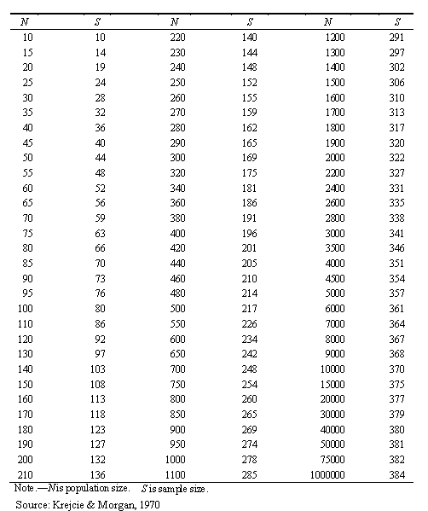

## **Appendix IV: Questionnaire**

**A STRATEGIC DECISION SUPPORT FRAMEWORK FOR ICT INVESTMENTS IN SMEs**

**A strategic decision** is a decision that affects the long-term direction of an organization, and involves allocating resources to achieve organizational goals.

**Decision support** refers to the use of tools and techniques to help decision-makers make more informed and effective decisions.

**ICT (Information and Communication Technology) investments** refer to investments in technology-based solutions that enable the processing, storage, and communication of information.

**SMEs (Small and Medium-sized Enterprises)** are businesses that have a limited number of employees and a relatively low turnover.

This framework aims to provide guidance to decision-makers in SMEs to help them allocate resources towards ICT investments that will help achieve their organizational goals in the long-term. The goal of this framework is to enable SMEs to make better decisions when investing in ICT, which will ultimately help them stay competitive in their respective markets.

**Section A: Profile**

1. What is your age group?

18-25 26-30 31-40 41-50 50 and above

1. What is your Gender?

Male Female

1. Highest level of formal education attained:

Certificate Diploma

Bachelors Masters PhD Others …………………………

1. What is your current role within the organization?

CEO/Managing Director/Owner Senior Manager/Executive

Middle Manager/Supervisor Junior Staff/Operational

1. How long have you been working in this role?

Less than 1 year 1-3 years 3-5 years 5 years or more

**SECTION B: Decision support and ICT tools**

1. What is your level of expertise in using ICT tools and technologies?

Beginner Intermediate Advanced Expert

1. How often do you use ICT tools and technologies as part of your job?

Rarely (less than once a month) Occasionally (once or twice a month)

Frequently (once or twice a week) Very frequently (Every day)

1. In your organization have you received any training or support to help you use ICT tools and technologies more effectively?

Yes No

1. What SMEs are you currently using in your company?

Computer hardware Software

Cloud computing Social media

E-commerce platforms Mobile devices

Virtual meetings Other (Specify)………………………..

1. What are the main challenges you face when using ICT tools and technologies?

Lack of skills/expertise Lack of access to technology

Technical problems or glitches Insufficient training or support

Other (please specify) ……………………………………………

1. How do you think ICT investments can help improve the organization's performance?

Improve efficiency and productivity Enhance communication and collaboration

Streamline processes and operations Expand customer reach and engagement

Other (please specify) …………………………………………………….

1. How does your organization currently invest in ICT?

Purchasing hardware or software Upgrading existing technology

Implementing new systems or processes

Developing new products or services that require ICT

Other (please specify) ……………………………………………………….

1. What are the key ICT investments made by your organization in the past year?

Hardware (e.g. computers, servers, mobile devices)

Software (e.g. applications, platforms)

IT infrastructure (e.g. networking, security) Training and development

Other (please specify) …………………………………………………

1. How are ICT investment decisions made in your organization?

Top-down approach (decisions made by senior management)

Bottom-up approach (decisions made by front-line staff)

Collaborative approach (decisions made through consultation and consensus-building)

Other (please specify) ……………………………

1. Have you been involved in any decision-making processes related to ICT investments?

Yes, I have been directly involved in decision-making processes

No, I have not been directly involved in decision-making processes but have provided input or feedback

No, I have not been involved in decision-making processes at all

1. What are the potential benefits of successful ICT investments for your organization?

Improved efficiency and productivity Increased revenue or profitability

Enhanced customer satisfaction or engagement

Expanded market reach or business opportunities

Other (please explain) ……………………………………………………..

**SECTION C: Challenges faced when making ICT investment**

Please indicate your level of agreement with each of the statements in this section by selecting only one option, which can be Strongly Disagree (SD), Disagree (D), Neutral (N), Agree (A), or Strongly Agree (SA), by placing a tick mark beside it.

|  |  |  |  |  |  |  |
| --- | --- | --- | --- | --- | --- | --- |
| S/N | What are the main challenges your organization faces when making ICT investments? | SA (5) | A (4) | NA (3) | D (2) | SD (1) |
| 1. | Limited budget or resources; It limits the organization's options and force them to choose cheaper, less effective solutions or delay their ICT investments altogether. This can lead to missed opportunities for increased efficiency, productivity, and competitiveness. |  |  |  |  |  |
| 2. | Uncertainty about the return on investment: This leads organizations to be hesitant in investing in new technologies or delay investments altogether. |  |  |  |  |  |
| 3. | Difficulty in aligning ICT investments with organizational goals and strategies: This leads to wasted resources and missed opportunities. |  |  |  |  |  |
| 4. | Lack of expertise or knowledge in ICT decision-making: This leads organizations to make poor investment decisions due to lack of necessary expertise to evaluate and select the right technology solutions, hence investing in solutions that do not meet their needs or do not integrate well with their existing systems. |  |  |  |  |  |
| 5 | Resistance to change or adoption of new technology: This hinders ICT investments by slowing down the implementation process or making it more difficult to achieve buy-in from employees. |  |  |  |  |  |

**SECTION D: proposed solution to improve decision support in ICT investment**

Please indicate your level of agreement with each of the statements in this section by selecting only one option, which can be Strongly Disagree (SD), Disagree (D), Neutral (N), Agree (A), or Strongly Agree (SA), by placing a tick mark beside it.

|  |  |  |  |  |  |  |
| --- | --- | --- | --- | --- | --- | --- |
| **S/N** | **The proposed ICT investment decision support framework can help solve the challenges affecting SMEs through the following ways:** | **SA (5)** | **A (4)** | **NA (3)** | **D (2)** | **SD (1)** |
| 1 | The framework will consider budget and ICT needs to help prioritize ICT investments based on their strategic fit with organizational goals and potential for cost savings or efficiency gains. |  |  |  |  |  |
| 2 | The framework will support risk analysis and evaluation through providing tools for cost-benefit analysis, risk analysis, and other methods to maximize the value of ICT investments. |  |  |  |  |  |
| 3 | The framework will provide a structured approach to evaluating potential ICT costs and investments, including analysing the potential benefits and risks of each option. It can also help develop clear goals and performance metrics to measure the success or impact of ICT investments. |  |  |  |  |  |
| 4 | The framework will help align ICT investments with organizational goals and strategies by providing a structured process for assessing the strategic fit of potential investments, and engaging stakeholders in the decision-making process |  |  |  |  |  |
| 5 | The framework can help address resistance to new technology by engaging stakeholders in the decision-making process, ensuring that the benefits of new technology are communicated clearly, and providing training and support to help staff adopt new technology effectively. |  |  |  |  |  |

1. What suggestions do you have to improve the organization's approach to ICT investments and decision-making?

Improve communication and collaboration across departments/teams

Increase training and support for staff

Develop a clear and structured framework for decision-making

Conduct more thorough analysis and evaluation of ICT investment options

Other (please specify)